TSOP - IR Receiver Interfacing to Arduino:
Introduction:
The TSOP SM0038 is an IR receiver. The TSOP will help you to interface your TV remote with the Arduino and in the Process learn the basics of Wireless Communication. The TSOP outputs a constant HIGH signal when idle and as it receives data, it tends to invert the data. i.e when an IR LED is transmitting data onto the TSOP, everytime the IR led goes high, the TSOP will go LOW and vice versa. Remote control signals are often bytes of data that is encoded and transmitted by pulsing(switching ON & OFF the IR LED at a specific frequency) Most TV remote controls work at 32-40 Khz frequency and most receivers can receive this range.

Requirment:
- One TSOP IR Receiver
- Arduino Board
- Breadboard

Hardware configuration:
first one the pin mapping of TSOP – IR as shown in given below.

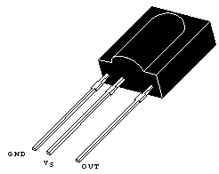

Step1:Place the TSOP on the Breadboard
Step2:Connect a wire between the 1st pin of the TSOP and the '-'ve terminal
Step3:Connect a wire between the 2nd pin of the TSOP and the '+'ve terminal
Step4:Connect a Wire between the 3rd pin of the TSOP and digital pin 12 of the Arduino
step5:connect all LCD connection as previous document.

Therfore final setup as shown is given below.

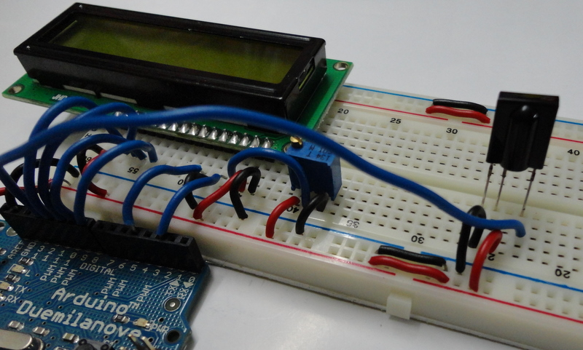
Programing:(source code):

Programming to control the TSOP - IR Receiver:

/*
*IRremote: IrrecvDemo - demonstrates receiving IR codes with IRrecv
*AnIRdetector/demodulator must be connectedotheinput RECV_PIN.
*Version0.1July,2009
*Copyright2009 Ken Shirriff
*http://arcfn.com
*/

#include<IRremote.h>

int RECV_PIN = 12;

Irrecv irrecv(RECV_PIN);

decode_results results;
int remote = 0;

void setup()
{
Serial.begin(9600);
irrecv.enableIRIn();// Start the receiver
}

void loop() {
if (irrecv.decode(&results)) {
remote = results.value;
Serial.println(remote);
irrecv.resume();// Receive the next valu
}
}

Now lets try to display the remote button value on the LCD.
#include <IRremote.h>
#include <LiquidCrystal.h>
/*
List of Values corresponding to numbers of the remote being pressed, remember to eplace thesevalues with the values you get.
1 16
2 2064
3 1040
4 3088
5 528
6 2576
7 2960
8 3600
9 272
0 2320
*/
//initialize the library with the numbers of the interface pins
LiquidCrystal lcd(2,4,8,9,10,11);

int RECV_PIN = 12;

Irrecv irrecv(RECV_PIN);

decode_results results;
int remote = 0, display_value=0;

void setup()
{
lcd.begin(16,2);
irrecv.enableIRIn();// Start the receiver
}

void loop() {
if (irrecv.decode(&results)) {
remote=results.value;
switch(remote)
{
case 16 : display_value=1; break;
case 2064 : display_value=2; break;
case 1040 : display_value=3; break;
case 3088 : display_value=4; break;
case 528 : display_value=5; break;
case 2576 : display_value=6; break;
case 2960 : display_value=7; break;
case 3600 : display_value=8; break;
case 272 : display_value=9; break;
case 2320 : display_value=0; break;
}
lcd.clear();
lcd.print(display_value);
irrecv.resume(); // Receive the next value
}
}
Installation:
The source code copy to the skeches of arduino and compile (there is verify option) as shown given below.
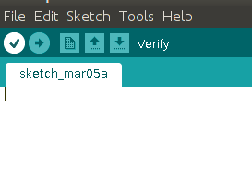

And then uploding the source code.(there is uploding option) to the Arduino board.(software) as shown given below.
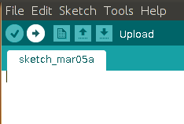

Troubleshooting: ones the code is not working then you will go to the IR remote lib installation. You are downlode the IR remote libreries and install the Arduino Board and then repet all thinks ones again.
FAQ:
Maintainers:
Duryodhan Aldar (durva.ges@gmail.com)

References: http://quickstartkitforarduino.blogspot.in/

